**PRACTICAL APPLICATION OF DATABASE MANAGEMENT IN INDUSTRIES (Report)**

Submitted by

**Name:**

**Matric Number:**

Computer Science Department

Lagos State University

February 2024

**Introduction:**

In today's business landscape, efficient record management is crucial for organizational success. The manual approach to record keeping, prevalent in many businesses, often leads to inefficiencies and errors. To address this challenge, computer scientists advocate for the automation of record management through the utilization of database management system (DBMS) concepts. This report explores the application of these concepts in the development of a Web-based Task Tracker software, aimed at improving task management efficiency.

**1. Database Creation:** The foundation of the Web-based Task Tracker lies in the creation of a robust database structure. Using phpMyAdmin, a popular web-based tool for managing MySQL databases, the database was created with the following steps:

* **Database Creation:** A new database named "taskdb" was created to store task-related data. This was achieved by accessing phpMyAdmin, navigating to the database section, and entering the desired database name.

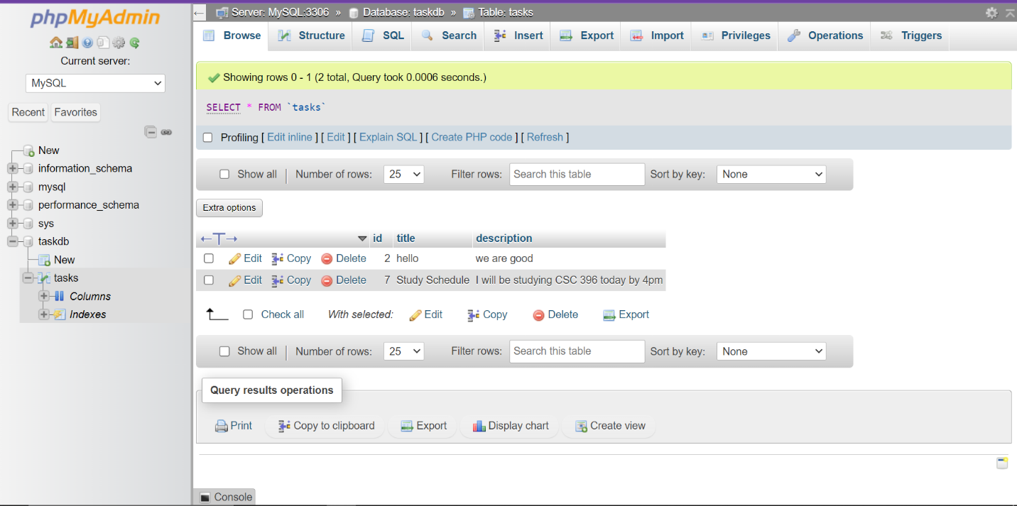

* 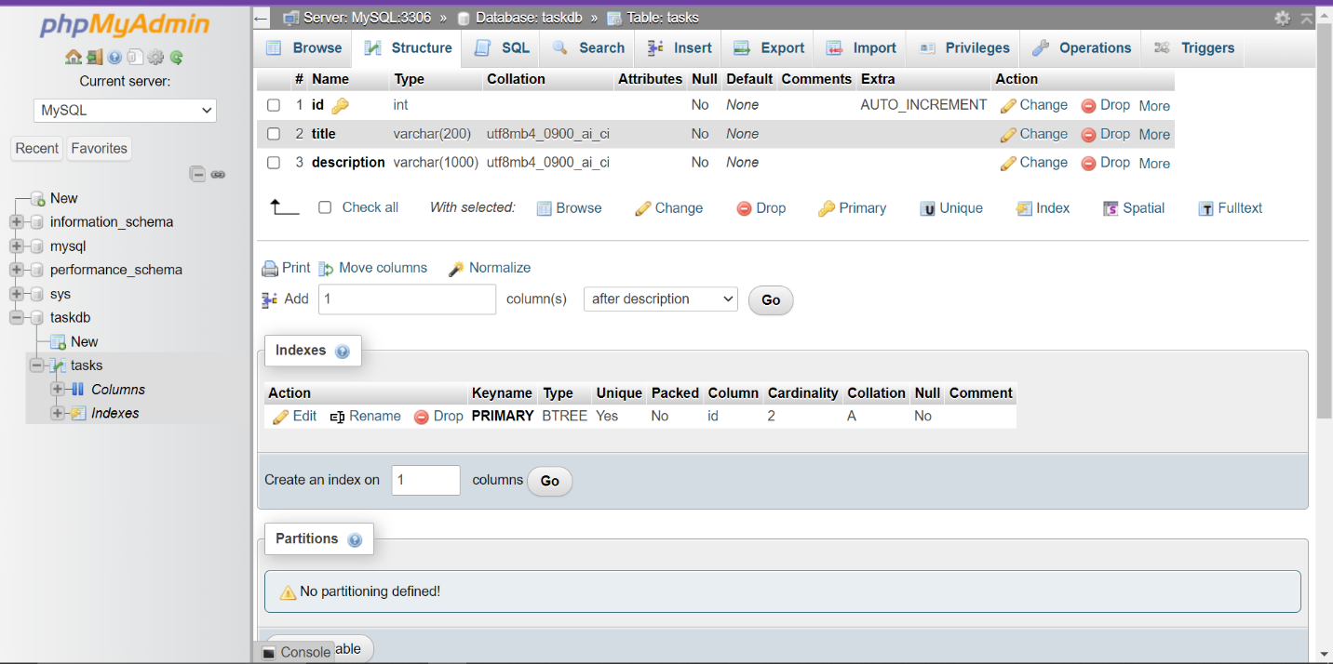**Table Creation:** Within the "taskdb" database, tables were created to store task information. These tables include fields such as task title, description, and task ID to uniquely identify each task. The table structure was designed to ensure efficient data storage and retrieval.
* **Field Definitions:** Each field within the tables was carefully defined to enforce data integrity and facilitate effective querying. Data types such as VARCHAR, TEXT, and INT were used to accurately represent different types of task information.

**2. Database CRUD Operations:** The Web-based Task Tracker allows users to perform CRUD operations (Create, Read, Update, Delete) on task data, empowering them to efficiently manage their tasks. The following CRUD operations were implemented:

* **Create:** Users can add new tasks by providing a title and description through a user-friendly interface. Upon submission, the task details are inserted into the database, creating a new task entry.
* **Read:** The task list page displays all existing tasks stored in the database, allowing users to view task titles and descriptions at a glance. This read operation provides users with quick access to their task information.
* **Update:** Users have the ability to edit existing tasks by modifying the title or description fields. Upon submission of the updated information, the corresponding task entry in the database is updated, ensuring data accuracy.
* 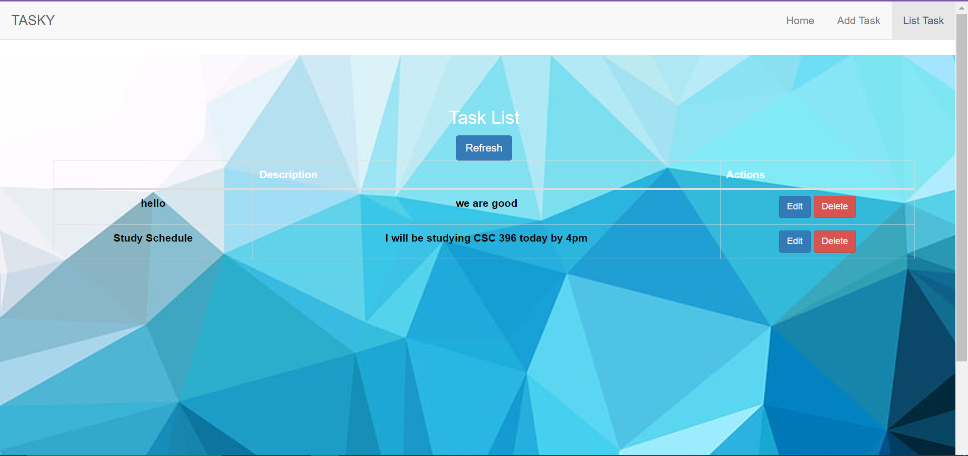**Delete:** Tasks can be deleted from the system, removing them from the database entirely. This delete operation ensures that outdated or irrelevant tasks are effectively removed from the task list.

**3. Front-end Integration and Reporting:** In addition to database CRUD operations, the Web-based Task Tracker integrates front-end programming to enhance user experience. Using PHP, HTML, CSS, and JavaScript, the task tracker application offers:

* **User Interface:** A visually appealing and intuitive user interface facilitates seamless interaction with the task tracker software. Users can easily navigate between different functionalities and access task management features.

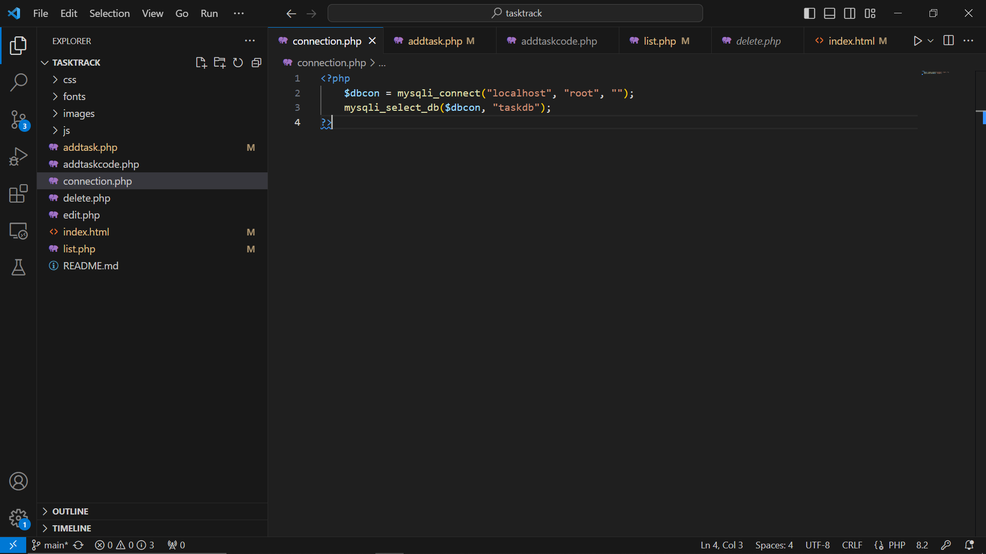

**Conclusion:**

The development of the Web-based Task Tracker software demonstrates the effective application of database management concepts. By leveraging modern technologies and methodologies, businesses can streamline task management, improve efficiency, and make informed decisions based on accurate and accessible data. This course equips me with the essential skills and knowledge to address the challenges of manual record keeping through the automation of database management, paving the way for enhanced business efficiency and success.